<https://plotdigitizer.com/app>

<https://www.desmos.com/calculator/qsdscncgi6>

-0.313441*(**'Inverter deltaP'** [bar]*10.1972)^2-1.06773\***'Inverter deltaP'** [bar] * 10.1972+33.71431

Equation implemented with actual data

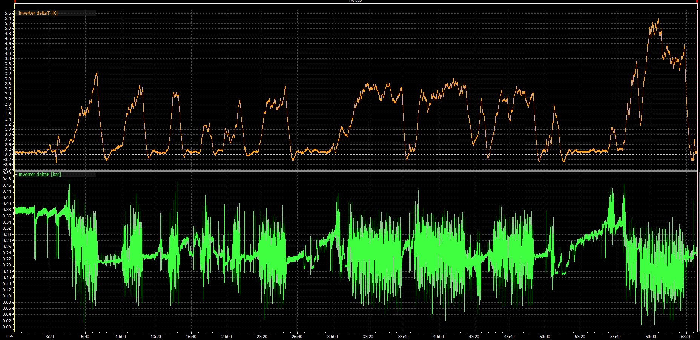

Change in temperature and pressure across the inverter

New Datalogging Channels

